**Kol simcha torah gazette**

**For parshas Vayikra/purim 5784**

Volume 8 Issue 28 (Whole #386) 13 Adar Sheni 5784/ March 23, 2023

**Printed L’illuy nishmas Nechama bas R’ Noach, a”h**

For a free subscription, please forward your request to [***keren18@juno.com***](mailto:keren18@juno.com)

***Past emails can be found on the website ShabbosStories.com under Brooklyn Torah Gazette***

**Purim and the Betrayal of American Jewry**

**By**[**Tzvi Freeman**](https://www.chabad.org/search/keyword_cdo/kid/193/jewish/Freeman-Tzvi.htm)



If there is any one word that can describe the emotional reaction of Jews to the sudden flood of antisemitism in America today, it is “betrayed.”

Who has betrayed us? Not the white supremacists, not the neo-Nazis and the ignorant, brainwashed skinheads—there’s no element of surprise there—but the educated, humanitarian left, that segment of society that Jews have embraced more than any other, both ideologically and socially. The gentle souls who walked with us in sympathetic conversation have turned with teeth, claws, and venom against us.

What prompted their betrayal? Because they saw that it was possible to murder, rape, and torture over 1,200 of us, abduct our babies and elderly, and get away with it. That was “exhilarating” and “awesome.” That very morning, there were those who jumped out of bed eager to blame the victims, defend murderers and rapists, and celebrate our pain.

**Dampening the Perverse Antisemitic Exhilaration**

Only later were they angered that we dare attempt to rescue our loved ones and protect ourselves from those who would destroy us, dampening the perverse antisemitic exhilaration that comes from seeing a Jew suffer.

Why is betrayal so shocking? Because it redefines not only the present but the past. It means that all along, the people you thought were your friends were holding a dagger for you in their back pocket. It disrupts your sense of reality so that you are now forced to think and live in an entirely different way.

The Jewish people, on their long trek through history, carry a sort of mirror, a statement of a time that was then as it is now, here as it was there, because it continues to play and replay in endless variations. There’s a time for pulling this mirror out, around winter’s end, as the blossoms begin to appear, on [Purim](https://www.chabad.org/holidays/purim/article_cdo/aid/645309/jewish/What-Is-Purim.htm). It’s called the [Scroll of Esther](https://www.chabad.org/holidays/purim/article_cdo/aid/1473/jewish/The-Megillah.htm), or just “the Megillah” (the Hebrew word for scroll).

The story of Esther takes place in the world’s first cosmopolitan civilization, the Persian Empire. With a network of highways and the first postal system, with appointed governors over lands from Ethiopia to the Indus Valley, comprising a vast diversity of some 60 million people, the Persian Empire by necessity relied on a policy of tolerance.

**We Had Made Great Contributions**

**to Their Economy, Their Culture…**

We had been exiled from our land to the heart of this empire for over three generations. As an educated class, we had made great contributions to their economy, their culture, and their civilization. Among us were scribes, scholars, political advisors, such as [Daniel](https://www.chabad.org/library/article_cdo/aid/3630049/jewish/Daniel-the-Prophet-of-the-Bible.htm), [Mordechai](https://www.chabad.org/holidays/purim/article_cdo/aid/5833064/jewish/Who-Was-Mordecai.htm), and even the queen herself, [Queen Esther](https://www.chabad.org/library/article_cdo/aid/4297202/jewish/Who-Was-Esther.htm).

Perhaps we will discover divine meaning in all this pain, that all we really have is that which we had from the beginning.

The capital city of Shushan was filled with successful Jews. When the king made a banquet for all the city’s inhabitants, we were there, and we were treated no differently than any other subjects of the king. In the royal palace, a Jew could ask for [kosher food](https://www.chabad.org/library/article_cdo/aid/113425/jewish/What-Is-Kosher.htm) and be served it, or for whatever food or wine he or she may please.

And then the news arrives that the king has secretly signed off on Haman’s plan to render his empire Judenrein. It makes sense that we would be left in shock (as the Megillah puts it[1](javascript:doFootnote('1a6366328');)). We had been betrayed by the empire we had come to consider our home. It was a shock perhaps even more sudden and bewildering than that which American Jewry experienced on October 8, 2023.

**Pretending that You Were Just**

**Another Fire-Worshiping Persian**

In Ancient Persia, it probably wouldn’t have helped to stand up at a public award event and declare that you don’t consider your Jewishness a justification for whatever blood-libel Haman’s thugs had fabricated. Or to publicly divorce yourself from the actions of Mordechai and his refusal to bow to Haman. On the other hand, you could likely escape the wrath of Haman’s protesters by getting out of your typically Jewish mode of dress and pretending you were just another fire-worshiping Persian.

But this magical mirror tells us, no, that is not what saved us. No Jew at that time even considered jumping ship.

Haman had declared we were a scattered, fragmented people.[2](javascript:doFootnote('2a6366328');) So we united as one.[3](javascript:doFootnote('3a6366328');)

As Esther instructed Mordechai, “Go, gather all the Jews.” And as many midrashic accounts describe at length.

Of course, being united didn’t change the minds of Haman’s terrorists. Neither did it directly change the mind of the king. It worked for only one reason: Because we are not a normal people. We do not exist within the natural universe. We are a special people with a G‑d-given task to bring His oneness into this crazy world. And only when we embrace that task of oneness can we rise above the natural ramifications of being the proverbial lamb among seventy wolves.

**What Does the Concept of Jewish Unity Mean?**

What does it mean to be united as one? Does it mean that we all agree on everything? In the Jewish sense of the term, definitely not.

Jewish unity means that we listen to one another, care for one another, and work together for the good of us all. That gives us strength, and the strength brings with it more unity.

When Jews feel united, we are not afraid to stand out as Jews, to do the things Jews do in public, to stick [mezuzahs](https://www.chabad.org/library/article_cdo/aid/256915/jewish/What-Is-a-Mezuzah.htm) to the doorposts of our homes and offices, to request a kosher meal at the office lunch party, or to turn up at school or work one day with a kippah.

It empowers us to embrace a new, lucid notion of reality—the notion that we are here with a purpose to change the world, that we have largely succeeded, and that those who despise us are those who despise change for the good. They themselves may not recognize their resistance, their subliminal desire to return to the savagery of pre-modern times. They may cloak themselves in a gown of humanitarian concern, dressed with the badges of the struggle of the oppressed.

**Choosing the Direction You Wish**

**to Travel on History’s Highway**

But the masquerade is over, the masks have been removed, and everyone now knows what the word “Zionist” really means when issued from their histrionic mouths. It’s up to each one to choose which direction you wish to travel on history’s highway.

This is the miracle of our current situation: The Jewish people have never been so united. Past pogroms and outbursts of antisemitism brought fear, anger and assimilation in their wake. This horrific attack has acted as a great *shofar*call to bring us together. Perhaps for the first time in Jewish history, there is a shortage of *tefillin*, as scribes struggle to keep up with the demand. It’s becoming increasingly difficult to find a Jewish woman who does not light Shabbat candles.

Perhaps we will discover divine meaning in all this pain, that all we really have is that which we had from the beginning.

**A Request for Togetherness, Unity**

**and Pushing Away Extremism**

Last week, Brigadier General Dan Goldfus, much-admired commander of the 98th division of the IDF, spoke to his nation with great emotion. “From my heart,” he pleaded, “I ask of you to be together, united, to push away the extremism, and to adopt togetherness. Find what unites us. We on the battlefield found it and we will not give up on it. Make this all worthwhile.”

There are many who do not believe in us. But we believe in ourselves. We look in our mirror and we see, as in the Purim story, that the tables will soon be turned. And if the darkness can become light, and our pain transformed to joy, then, too, perhaps this time around, all the hatred in the world can be forever put to rest. For real.

**FOOTNOTES**

[1.](https://www.chabad.org/holidays/purim/article_cdo/aid/6366328/jewish/Purim-and-the-Betrayal-of-American-Jewry.htm" \l "footnoteRef1a6366328) [Esther 3:15](https://www.chabad.org/16476#v15). [2.](https://www.chabad.org/holidays/purim/article_cdo/aid/6366328/jewish/Purim-and-the-Betrayal-of-American-Jewry.htm#footnoteRef2a6366328) [Esther 3:8](https://www.chabad.org/16476#v8). [3.](https://www.chabad.org/holidays/purim/article_cdo/aid/6366328/jewish/Purim-and-the-Betrayal-of-American-Jewry.htm#footnoteRef3a6366328) [Esther 4:16](https://www.chabad.org/16477#v16);

*Reprinted from this week’s website of Chabad.Org*

**Rav Avigdor Miller on**

**Can Learning Torah be**

**Greater than Saving Lives?**

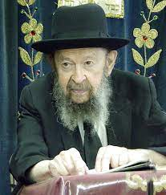

**QUESTION:** There’s a statement there from Rav Yosef (Megillah 16b) who says that learning Torah is greater than saving lives. I don’t understand that. Maybe Rebbe can explain that to us?

**ANSWER:** Yes. The Gemara states that Mordechai at the beginning was a leader of all the Jews and at the end of the whole episode it says he was accepted by most of his brothers. “Most” means not all. So, the question is, after this great salvation which Mordechai helped bring about, he surely should have been accepted by everybody. So why did he lose out with some of his brothers?

So, the Gemara says because the study of the Torah is greater than saving Jews. And during this time that he was busy in the king’s palace, he lost some time from the study of the Torah. And therefore, at the beginning when he was all Torah, he had saved nobody, he was accepted by all his brothers.

At the end, he had to spend some time in the king’s service; after all he was appointed as the king’s right hand and he was given the king’s ring at the end, so he had to lose some of the time from learning and so he was accepted by “most” of his brothers, not by all of them. And it’s because the study of the Torah is the greatest distinction a Jew can have. So, what’s the problem?

**QUESTION:** But aren’t all the Torah leaders of the Am Yisrael obligated to be mevatel Torah for hatzalas nefashos?

**ANSWER:** Certainly, you have to. You have to stop Torah for kiddush levanah too. For any custom, you have to stop the learning of the Torah. No question, you have to stop learning. And still, when Hakadosh Baruch Hu doesn’t send such a mitzvah to a Jew and allows him to study the Torah in peace, he’s more fortunate. Because the greatest gift to a man is perfection in the Torah. If you have to stop to save somebody’s life, you must stop. There’s no such thing as not stopping! But the time that you lose is deducted from your perfection.

However, in the next world, there are two Gan Edens; a Gan Eden for Torah and a Gan Eden for good deeds.

*Reprinted from the Parshas Pekudei 5784 email of Toras Avigdor. Transcribed from Tape #R-34 (March 1972).*

**Thoughts that Count**

**For Parshat Vayikra**

*And He called to Moses* (Lev. 1:1)

Of all the righteous people who lived in that generation - Aaron, the Seventy Elders, Betzalel and Chur - why did G-d call only to Moses? Because Moses was a person who "fled from power," as our Sages stated: "He who pursues authority and power, authority and power flee from him; he who flees authority and power, authority and power pursue him." *(Tanchuma)*

**The Two Extremes of “Leaven” and “Honey”**

*For you shall burn no leaven, nor any honey, in any offering of the L-rd made by fire* (Lev. 2:11)

"Leaven" and "honey" are two extremes; by taste and attributes, they are opposites of each other. The Torah teaches that any kind of extreme should be avoided. A Jew must always seek the middle road, "the golden path." *(Rabbi Yosef Shaul Nathanson)*

*Reprinted from the Parshat Vayikra 5761/2001 edition of L’Chaim Weekly. Adapted from volume 1 of Sefer HaSichot 5750.*

**G-d’s Call of Affection**

**To Every Single Jew**

**From the Teachings of the Lubavitcher Rebbe**

**Rabbi Menachem Mendel Schneerson, Zt”l**

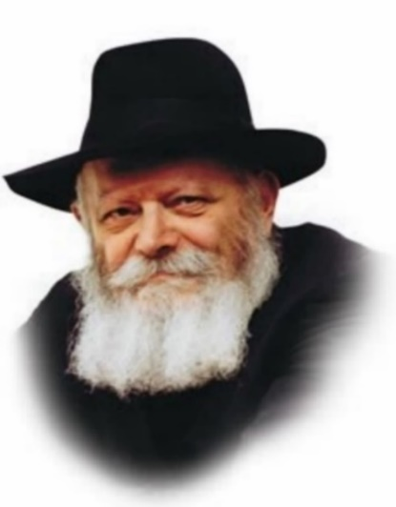

This week's Torah portion is the first portion in the Book of Leviticus-Vayikra. The Book of Leviticus, which deals primarily with the laws of sacrifices, opens with the words "And He [G-d] called (Vayikra) to Moses." According to Rashi, the foremost Torah commentator, this expression "is language indicating affection." G-d called out to Moses as a manifestation of His love.

Chasidut explains that the fact that the Torah does not specify by name who is calling is significant. G-d's call to Moses is derived from His Essence, which transcends all Names or descriptions. Similarly, G-d's affection for Moses also stems from His very Essence.

**A “Spark” of the Soul of Moses**

Every Jew possesses a "spark" of the soul of Moses; G-d's "call of affection" is thus directed to every individual Jew. In Leviticus, G-d teaches us how to offer the korbanot (sacrifices), from the root word meaning closeness. By means of the korbanot, one is able to draw closer to G-d.

This same idea is also expressed in the haftorah that is usually read after the portion of Vayikra, which begins with the words "This people have I formed for Myself; they shall proclaim My praise." Like the opening verse of Leviticus, these words describe G-d's tremendous love for His people.

The simple explanation of the verse is that the Jews proclaim G-d's praise through their actions, i.e., by observing G-d's commandments, studying His Torah and praying to Him. But on a deeper level, G-d is "praised" independent of the Jewish people's conduct and even their will. This is the natural consequence of the Jews' very existence, and nothing else.

The first half of the verse describes the Jews' fundamental nature: "This people have I formed for Myself." By mere virtue of his existence a Jew belongs to G-d, having been created specifically for that purpose.

**A Jew Proclaims G-d’s Greatness Just by Being Alive**

However, the Jewish people "proclaim G-d's praise" in the collective sense as well. The simple fact that the Jews - "a sheep among 70 wolves" - have survived while other, mightier nations have disappeared off the face of the earth, is a tribute to the Alm-ghty. A Jew proclaims G-d's greatness just by being alive.

This is especially true in our generation, the generation after the Holocaust. Whenever one sees a Jew continuing the tradition and passing Judaism along to the next generation, it is a living miracle of the Holy One, blessed be He.

G-d loves every Jew with an essential love regardless of his actions. From this we learn how important it is to love our fellow Jews unconditionally, judge them favorably, and always treat others with respect. For "This people have I formed for Myself; they shall proclaim My praise!"

*Reprinted from the Parshat Vayikra 5761/2001 edition of L’Chaim Weekly. Adapted from volume 1 of Sefer HaSichot 5750.*

**More Thoughts that**

**Count for Our Parsha**

*When a person will sin unintentionally from among all the commandments of G-d that may not be done...for his sin that he committed he shall bring...a sin-offering* (Lev. 4:2-3)

Why should a person be expected to bring an offering for a sin he committed accidentally, i.e., without prior intent? The answer is that had he not already committed the same sin deliberately, G-d would have prevented him from being in a situation where he repeated it unintentionally. This is alluded to by the text itself: "When a person will sin unintentionally...for his sin that he committed." *(Rabbi Moses Alshich)*

*Reprinted from the Parshat Vayikra 5761/2001 edition of L’Chaim Weekly.*

**Rabbi Berel Wein on**

**Parshat Vayikra 5784**

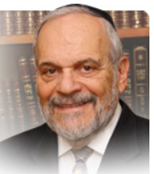

This Shabat we begin to read the book of Vayikra. This book of Vayikra has very little narrative to it and concentrates mainly on the sacrifices that were offered in the Temple service of the Mishkan and the Beit Hamikdash; the laws of purity and defilement; and a listing of many of the commandments of the Torah and Jewish ritual.

**A Difficult Section of Torah to Comprehend**

This makes this section of the Torah a difficult one to comprehend, internalize and attempt to teach to others. Our educational sense would have postponed the teaching of this book of the Torah until the years of maturity and life experience have fashioned us as Torah devotees and scholars. Yet the rabbis of Jewish tradition have ordained that children begin their Torah experiences by studying the book of Vayikra.

Their statement is: “Let those who are still pure and holy begin their education by studying the concepts of purity and holiness.” These are difficult concepts to study. They are states of being, more of the heart and soul than that of the mind.

Someone who does not ever deal in being holy and pure will never be able to fathom the secrets of the Torah that lie in this book of Vayikra. That person will only see a seeming hodgepodge of laws and rituals, many of which would be judged to be anachronistic in our “enlightened” age.

But our Torah is a Torah of experience and emotion as much as it is one of soaring intellect and deep analytical thought. To begin to understand these concepts, one must be, or at least strive to be, a person of holiness and purity. And that is a most significant lesson that the book of Vayikra teaches us.

**The Connection of the Sacrificial**

**Worship and the Laws of Purity**

Purity and holiness are inextricably bound to the overriding value of constant sacrifice in Jewish life. It is no coincidence that the laws of the sacrificial worship in the Temple are connected to the laws of purity in this book of Vayikra. Without sacrifice, constant daily sacrifice, purity and holiness are unachievable goals.

In a very contaminated environment, it is most difficult to keep one’s self clean and pure. It requires great discipline and restraint, care and will - in short, a supreme sense of sacrifice. In life we are always faced with myriad, daily choices. Every choice that we make indicates that we have sacrificed another choice that we could have made.

**A Sense of Holiness, Purity**

**and Purpose in Our Lives**

Then the only question that remains is whether we made the correct sacrifice. Will our choice bring us closer to a sense of holiness and purity and purpose in our lives or, perhaps, will it do the opposite? The seeming jumble of laws in the book of Vayikra is meant to guide our choices of which sacrifices we should wisely make in our lives.

The Torah details for us all of the categories of sacrifices – public, private, those of leaders and of paupers – and points the way to our sacrificing wisely and productively. This is the overall thrust of this great biblical book of Vayikra.

Shabbat shalom

*Reprinted from the current website of rabbiwein.com*

**Challah from**

**Hamantashen Batches**

**By Rabbi Hillel Raskin**



**Rabbi Hillel Raskin**

Do separate batches of hamantashen combine to necessitate hafrashas challa?

The mitzva of separating challah applies to dough from flour of the five grains amounting to the shiur of a tenth of an eifah, with a final product resembling bread.

To separate challa with a bracha, one should ensure that at least some of the liquid is water, or that any of the seven halachic “liquids” make up the majority of the dough’s liquid.

Baked pastries that get a bread-like consistency are obligated in challa if enough flour is used (with regular white flour – at least 2 lb. 11 oz. to separate without a bracha)

If the dough is loose before baking, challa should be separated after baking. If one is preparing two batches of hamantashen or rugelach and each dough is less than the shiur but collectively add up to the shiur, they can combine and become obligated under these conditions:

1. You don’t care if the doughs get mixed, and (2) the doughs are in one utensil (and covered on top if it rises above the utensil’s airspace). Likewise, if the baked pastries are stored together in one bag or container, the smaller batches that were originally exempt can combine to create a chiyuv of hafrasha.

Certain circumstances will prevent the batches from combining: (1) If they are made from different types of grain, (2) if people are careful that they not mix so they don’t taint each other, and according to some (3) even if they have different tastes or forms.

If the pastries remain in separate packages or were combined in a closet connected to the wall (and, hence, to the ground), it is doubtful if they become one. Separating challah from one doubtful batch on another can run the risk of separating from an exempt batch for one that is obligated.

Instead, one should be mafrish a tiny amount from each type on its own without a bracha. One should also avoid combining batches of similar pastries together (e.g. many hamentashen), as it might create a complete chiyuv.

*Reprinted from the Parshat Pekudei 5784 edition of The Weekly Farbrengen. Rabbi Raskin is Rov of Anash in Petach Tikva, Israel.*

**Henry Morgenthau’s**

**Queen Esther Moment**

7

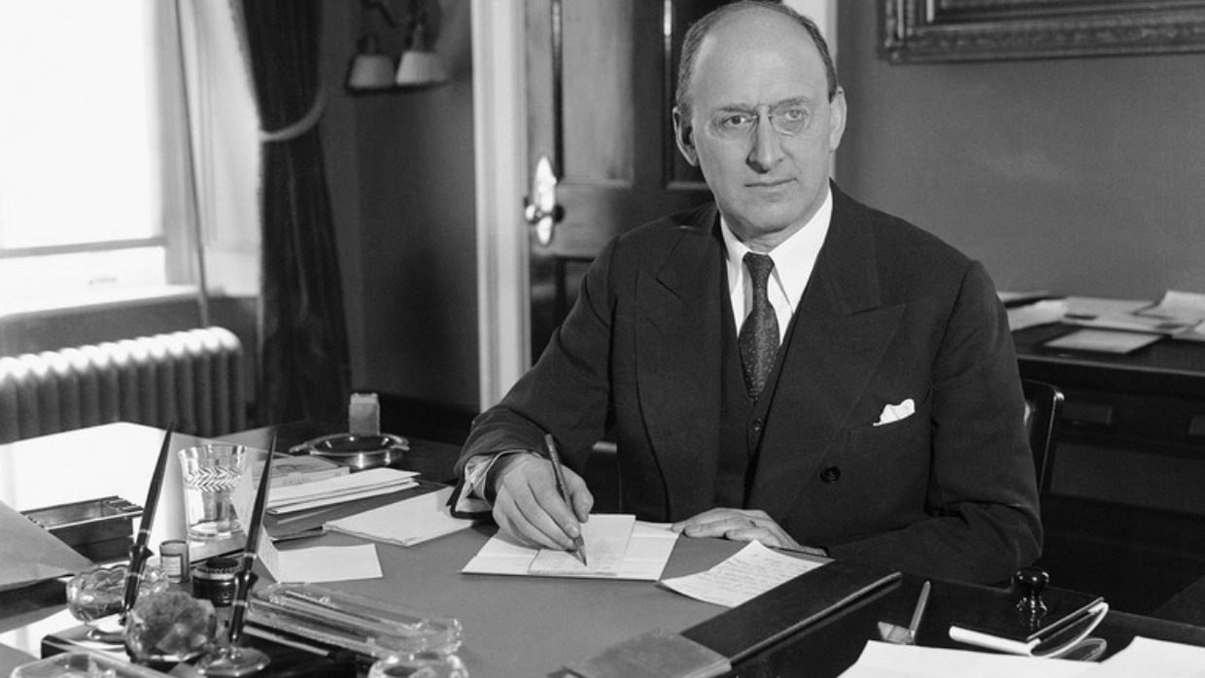

***The only Jew in FDR’s cabinet, the influential politician was in a position to stand up for being a Jew and help save Jewish lives during the Holocaust.***

On the holiday of Purim, Jews worldwide celebrate the salvation of the Jewish people in the ancient Persian empire. Haman, royal vizier to the Persian King Achashverosh, plotted “to destroy, kill and annihilate all the Jewish people, young and old, men and women, in a single day” (Scroll of [Esther, 3:13](https://www.sefaria.org/Esther.3.13?lang=he-en&utm_source=aish.com&utm_medium=sefaria_linker)).

In the face of Haman’s imminent genocidal decree upon the Jewish People, Mordechai directed his niece, Queen Esther, to approach the King and beseech him to save her people. Esther was understandably reluctant because she could be killed immediately for entering the king’s chamber without being summoned.

In the face of her demurral, Mordechai responded with strong words, telling her, “If you keep silent at this time, relief and deliverance will come to the Jews from another place, while you and your father's house will perish. And who knows, perhaps it is precisely for this opportunity that you became queen” ([Esther 4:14](https://www.sefaria.org/Esther.4.14?lang=he-en&utm_source=aish.com&utm_medium=sefaria_linker)).

*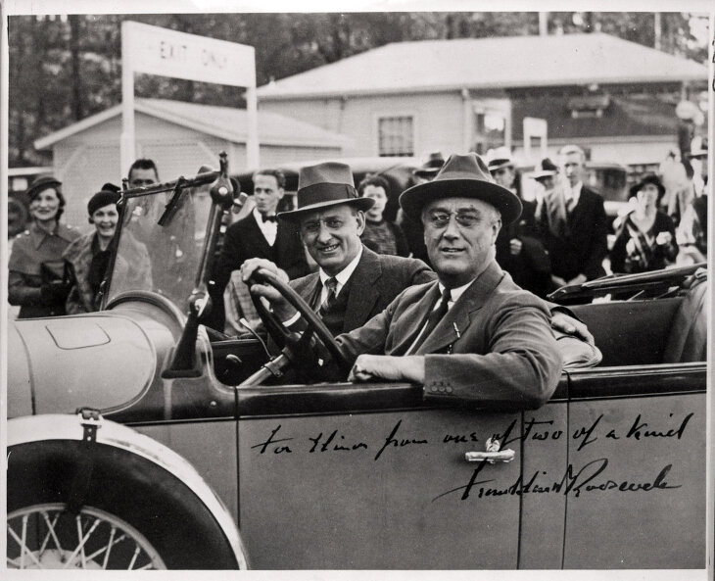President Franklin D. Roosevelt and Henry Morgenthau Jr. in a car on Feb. 9, 1934. The inscription by FDR reads “From one of two of kind.” | Franklin D. Roosevelt Presidential Library and Museum*

Understanding that this was the reason she had ascended to royalty and influence, Queen Esther made an immediate about-face. Rising to the occasion, she instructed Mordechai to tell all Jewish residents of Shushan to fast and pray for three days and nights and upon the conclusion of the three days, she would approach the king uninvited. “And if I am to perish, I shall perish…" (4:16)

Her strategy worked, Haman and his 10 sons were hung, and the Jewish people were saved by G-d.

Fast forward two millennia, another Jewish leader named Henry Morgenthau Jr. (1891–1967) would experience his Queen Esther Moment when the Jewish people were being threatened with annihilation. He was born in New York City to a prominent family of German Jewish descent. His father, Henry Morgenthau Sr., was a successful real estate investor and diplomat and had served as ambassador to the Ottoman Empire during the presidential administration of Woodrow Wilson.

Henry Morgenthau Jr. served as the United States treasury secretary in the Roosevelt and Truman administrations from January 1, 1934, until July 23, 1945. Morgenthau stabilized the US dollar during the Great Depression, helped finance the "New Deal," prepared the US economy for war, and later funded the war effort by selling war bonds.

He was the only Jewish person to serve as a cabinet member during Roosevelt's administration. He was very devoted and loyal to Roosevelt, despite the President’s failure to take concrete actions to save European Jewry from the Holocaust or allow Jews to save themselves by immigrating to the United States.

In 1943, several months after the US State Department confirmed Nazi Germany’s mission to annihilate all the Jews of Europe, Morgenthau became directly involved in the rescue of the Jews in Europe.

The catalyst for Morgenthau’s new-found involvement was the advocacy of two Jewish groups: The *Vaad Hatzalah* (The Rescue Committee), led by America’s leading Orthodox Rabbis, and the “Emergency Committee for the Rescue of European Jewry” led by Hillel Kook.

**Meeting with the President**

The *Agudath HaRabbanim* (Union of Orthodox Rabbis), led by Rabbi Eliezer Silver of Cincinnati, founded an organization specifically devoted to the rescue of European Jews called the *Vaad Hatzalah* ("Rescue Committee"). The Vaad was supported by all of Orthodox Jewry (Agudath Israel, Young Israel, Mizrachi, etc.). It was led by three of the greatest Sages of America: Rabbi Eliezer Silver, Rabbi Avraham Kalmanowitz, and Rabbi Aharon Kotler. The leaders of the Vaad were willing to do *anything*to save their fellow Jews, recognizing that saving lives was *the*priority.

*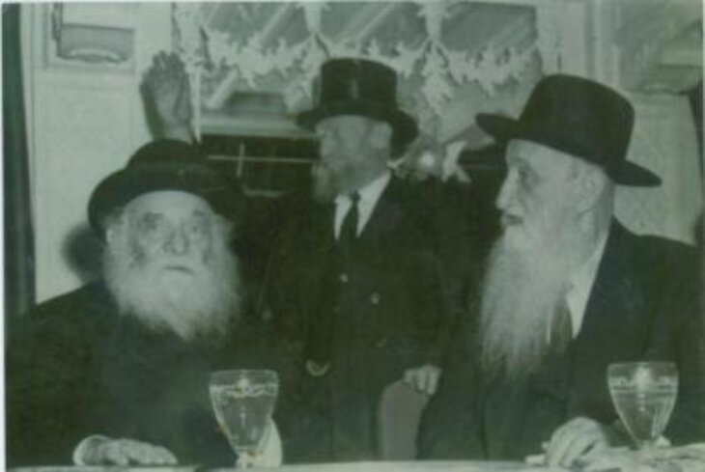Rabbi Aharon Kotler, Rabbi Eliezer Silver, Rabbi Avraham Kalmanowitz*

In mid-1943, the heads of Vaad Hatzlalah met with Morgenthau for the first time. Rabbi Kotler, Rabbi Kalmanowitz, and lay leader Irving Bunim pleaded with him to change American policy that had thus far done little to prevent the destruction of European Jewry. Visibly moved by the words of these great rabbis, Morgenthau called Secretary of State Cordell Hull and demanded a joint meeting with the President concerning the Nazi murder of the Jews in Europe.

When Hull politely refused, Morgenthau shocked him by responding, “If I do not get the meeting, my resignation will be on Mr. Roosevelt’s desk in the morning.” Morgenthau got his meeting with Roosevelt, and although it did not create immediate changes in US policy, it paved the way for creating the War Refugee Board a few months later.

**Jewish Activism and the Founding of the War Refugee Board**

The Bergson Group was led by Hillel Kook, one of the heads of Irgun in America and nephew of the First Chief Rabbi of Mandatory Palestine, Rabbi Abraham Isaac Kook. He also called himself Peter Bergson, thus the name of the group. He established the Emergency Committee for the Rescue of European Jewry. The Committee, which included Jewish and non-Jewish American public figures, worked to publicize the facts of the Nazi’s annihilation of the Jews and lobby the President and Congress to take action to save the remnants of Europe's Jews.

*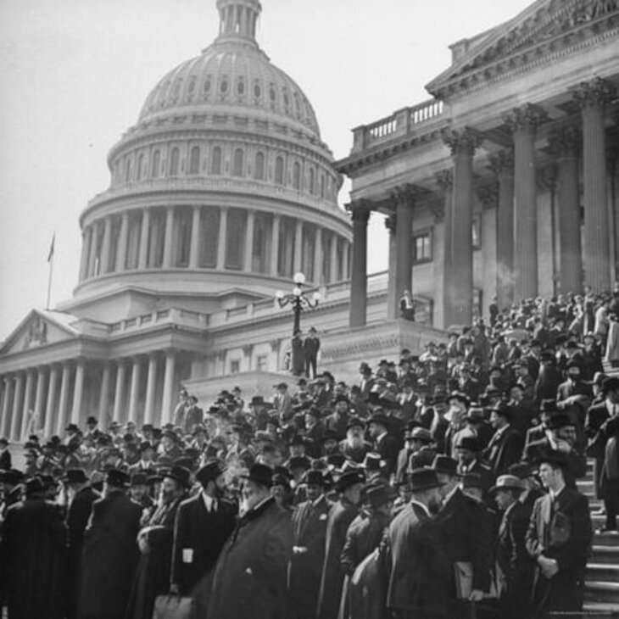The Rabbis March in Washington*

One of the Committee's more well-known actions was a protest Kook organized, known as the “Rabbis' March.” The protest took place in Washington, D.C., on October 6, 1943, three days before Yom Kippur. The group of over 400 rabbis marched to the United States Capitol, Lincoln Memorial, and White House in Washington, DC. The March’s success was limited by the actions of some of FDR’s Jewish friends (who were more concerned about FDR and less concerned for their fellow Jews in Europe), including Reform leader Stephen Wise.

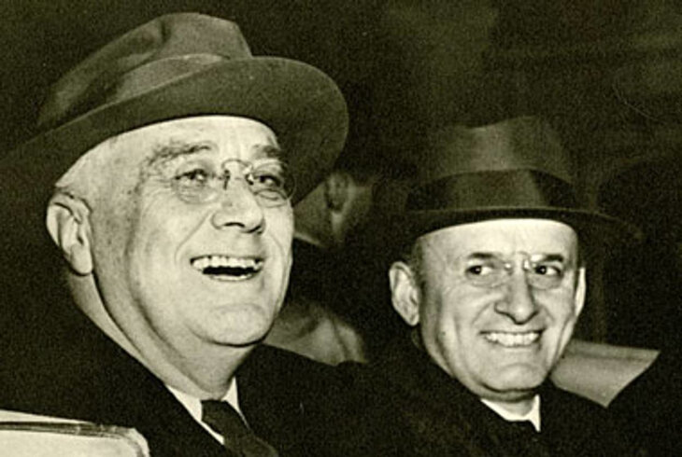

A few months later, on January 13, 1944. Treasury staff members John Pehle, Randolph Paul, Ansel Luxford, and Josiah DuBois presented Morgenthau with an 18-page memorandum entitled "Report to the Secretary on the Acquiescence of This Government in the Murder of Jews.” After reading it, Morgenthau’s immediate response was, “I am physically ill.”

As a result, three days later, on January 16, 1944, Morgenthau personally visited the White House and met with President Roosevelt. The following week, the president issued an executive order establishing the War Refugee Board on January 22, 1944.

Through the efforts of the War Refugee Board, steps were finally taken to save Jews in Europe. Refugee camps were prepared in North Africa, and safe havens were arranged in Palestine, Switzerland, and Sweden. The War Refugee Board also lobbied Roosevelt to publicly condemn the mass murder of Jews by the Nazis, which he did on March 24, 1944.

By attracting international attention to the desperate plight of Hungarian Jewry, the War Refugee Board contributed to the cessation of deportations of Hungarian Jews to Auschwitz. The Board also sent Swedish diplomat Raoul Wallenberg and others to protect the Jews of Budapest. The American Jewish Joint Distribution Committee funded Wallenberg's rescue work through the War Refugee Board. The work by Wallenberg in Hungary was one of the most successful and vital rescue efforts accomplished by the War Refugee Board.

It is difficult to determine the exact number of Jews rescued by the War Refugee Board. Professor David Wyman (1929-2018), a noted Christian Holocaust historian, credited the War Refugee Board with saving as many as 200,000 people; the War Refugee Board staff estimated they saved tens of thousands. At the end of the war, considering reports of ill-treatment of the Jews in the DP camps, Morgenthau and the War Refugee Board also convinced President Truman to send an American envoy, lawyer Earl Harrison, to examine the situation personally, and following his trip, the situation in the DP camps improved.

Yet, there was a time during the war when even Morgenthau hesitated.

**His Queen Esther Moment**

Shortly before Purim, in February 1945, Irving Bunim arranged for an urgent meeting with Morgenthau and was accompanied by Rabbi Aharon Kotler and Rabbi Avrohom Kalmanowitz, both of whom had escaped Europe and were using any means at their disposal to try to save the European Jews.

They came with a desperate request. The 'Musy Negotiations' were underway, which involved a payment of close to a million dollars to the Germans in exchange for releasing Jews from concentration camps and sending them to Switzerland.

The Vaad Hatzalah had the astronomical sum pledged to them by another Jewish organization. Yet, that organization insisted the Vaad receive official US government approval to transfer the funds through American agents in Switzerland. The Vaad Hatzalah appealed to Morgenthau to grant them official permission. Morgenthau responded that American foreign policy was not to pay ransom to the enemy: "Millions for defense but not one cent for tribute."

**“One Single Jewish Life is Worth More**

**Than all the Positions in Washington!"**

Rabbi Kotler did not speak English, and Secretary Morgenthau did not understand Yiddish, so Bunim had been serving as their translator. However, Morgenthau's tone was clear to Rabbi Kotler, even before Bunim said a word. The answer was NO.

Unable to hold back his emotions, Rabbi Kotler looked at Morgenthau with piercing blue eyes. With a voice shaking, he pointed at the Secretary of Treasury and said in Yiddish, "Bunim, tell him that if he cannot help rescue his fellow Jews at this time, then he is worth nothing, and his position is worth nothing! One single Jewish life is worth more than all the positions in Washington!"

After a few awkward moments, Bunim began translating, somewhat softening the Rabbi’s message as he spoke. Rabbi Kotler realized his words were not being conveyed accurately and cried in Yiddish, "*Nein, nein Bunim, zugt em vus ich hub gizugt!*No! Tell him exactly what I said!" Bunim realized that this was not a time for social niceties. He cleared his throat and silently prayed, knowing that countless Jewish lives hinged on his success.

"Sir… Rabbi Kotler feels that because you are afraid of losing your prominent position in the government, you may be unwilling to help us and your fellow Jewish brothers and sisters. He wants you to know that one Jewish life is worth more than any office."

Hearing this, Morgenthau turned white and placed his head on his desk, covering his face in his hands.

**"Tell the Rabbi that I am a Jew. Tell him I'm willing to give up my life — not just my position — for my people.”**

Finally, Morgenthau raised his head and cried, trembling with emotion, "Tell the Rabbi that I am a Jew. Tell him I'm willing to give up my life — not just my position — for my people.”

In the face of Rabbi Kotler’s challenge and words of truth, Morgenthau recognized his Queen Esther Moment. He rose to the occasion and enabled the Vaad Hatzalah to continue the negotiations, directly bringing about the release of 2,000 Jewish women from Ravensbruck. His actions live on eternally, in the lives he saved and the example he set.

We each have our own Queen Esther Moments. A time when we face a choice as to whether we will stand up for the Jewish people and Jewish values. It might be at work, on a college campus, or social media, on onstage at the Oscars. If you are able to stand up and do something, will you? Will you educate yourself and others on Jewish values and Israel’s right to defend itself? Will you proudly wear a Jewish symbol or kippah? Will you write to encourage elected officials and community leaders to support Israel and the Jewish people?

And, if you are like Morgenthau, someone in a position with real influence, will you act as he did, knowing there are values more important than your job or ephemeral popularity?

When your Queen Esther moment comes, what will you choose?

*Reprinted from the current aish.com website.*

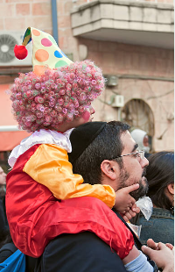

**Purim in Jerusalem(Yerushalayim)**